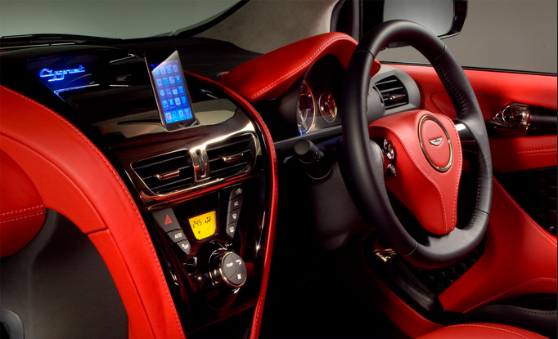

Meiqi You (25044621) & Jue Lu (25560565)

[Add Internet of Things equipment to a car to enhance the safety and comfort. This approach will involve car vehicle speed sensor and other external sensors, actuators. ]

Car Smart Console Proposal

FIT5140 Assignment 3 – An IoT based Mobile System

Table of Content

1. Introduction 3

2. Technology 3

2.1. Server 3

2.2. Microcontroller Unit 3

2.3. Sensors & Actuators 4

3. System Schematic 5

4. User Interface 6

# 1. Introduction

Car is part of life. However, not all cars running on Australian road are the modern style that with a brunch of equipment, such as Head Up Display, auto-heating seats, status monitor etc., that make life in car more safe and confortable.

When driving, car speed is extremely important for not only law reason, but also for the passengers’ safety. However, driver has to look down to check the speedometer, which distracts driver’s attention to the road. To help driver’s sight sticking on the road, the head up display will project the car speed on the wind screen translucently that driver can still see the road through the display.

Another problem is, in summer, the temperature inside a car would be high. The Car Smart Console will monitor the car internal temperature and when the temperature beyond certain degree, the console will turn on a humidifier to increase humidity. When the driver opens the car door, the higher humidity will evaporate which will help cool the inner space.

An iOS client will be used to monitor the temperature and humidity trends and can trigger the humidifier on demand. Also, each traveling with average speed, travel duration and GPS track would be checked on iOS client.

This approach will be extendable.

# 2. Technology

This approach will mainly consist of 3 parts.

## 2.1. Server

Server will be running on a Raspberry Pi board with debian Linux.

Node JS will be deployed on server that will collect data from Microcontroller Units via serial ports, control appliances and interact with iOS client via network.

Data will be stored in csv files (or MySql database, TBD).

## Microcontroller Unit

Arduino boards will be used as the MCUs.

MCUs will communicate with sensors, collect raw data from them, process the raw data and pass the data to server.

## Sensors & Actuators

1. Vehicle Speed Sensor (VSS)

VSS (car component) will be used to measure the wheels rotating frequency. Raw data will be processed to speed value.

2. Temperature & Humidity Sensor (THS)

THS will be used to measure the car inner temperature and humidity. Raw data will be processed to Celsius temperature and humidity percentage.

3. GPS (TBD)

Case 1:

A delegate GPS sensor would be used to get the geo-coordinate.

Case 2:

iOS client might sned the geo-coordinate back to server.

4. HUD (TBD)

Case 1:

2.2’’ OLED Screen will be used to project the speed.

Case 2:

A set of 3 7-segment LED will be used to project the speed.

74HC595 chips will be used to code the numbers.

5. Relay

Relay will be used as a auto-switch to turn on the humidifier.

6. Humidifier

Humidifier will generate humidity.

7. Liquid Level Sensor (TBD)

Liquid Level Sensor might be used to check the liquid level inside the humidity.

# 3. System Schematic

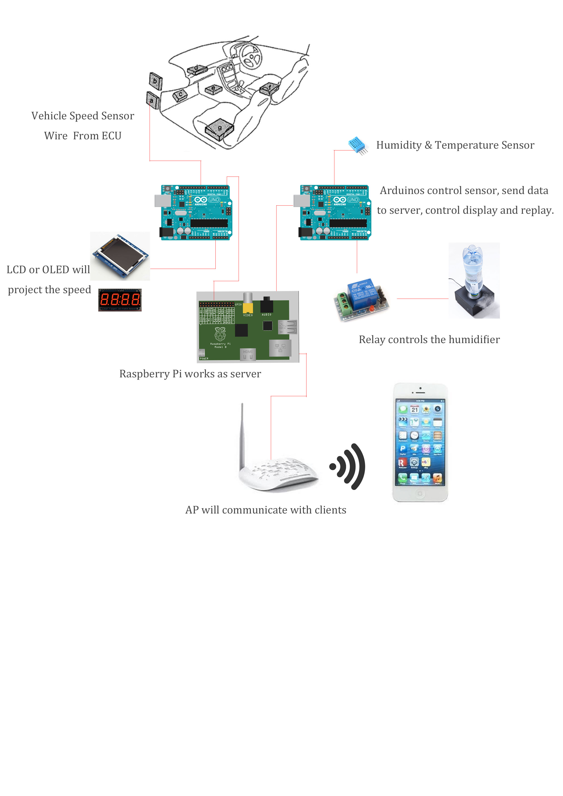

Arduino 1:

VSS connects to Arduino D5.

3 7-Segment LED connect to other Digital pins (LCD might use another delegate Arduino board).

Arduino 2:

Humidity &Temperature Sensor connects to Digital pins.

Realy connects to one digital pin. Replay also connects the humidifier.

Raspberry Pi:

USB serial ports connect 2 Arduino boards.

Ethernet Port connects to AP.

Communicate with iOS clients via coAP.

# User Interface

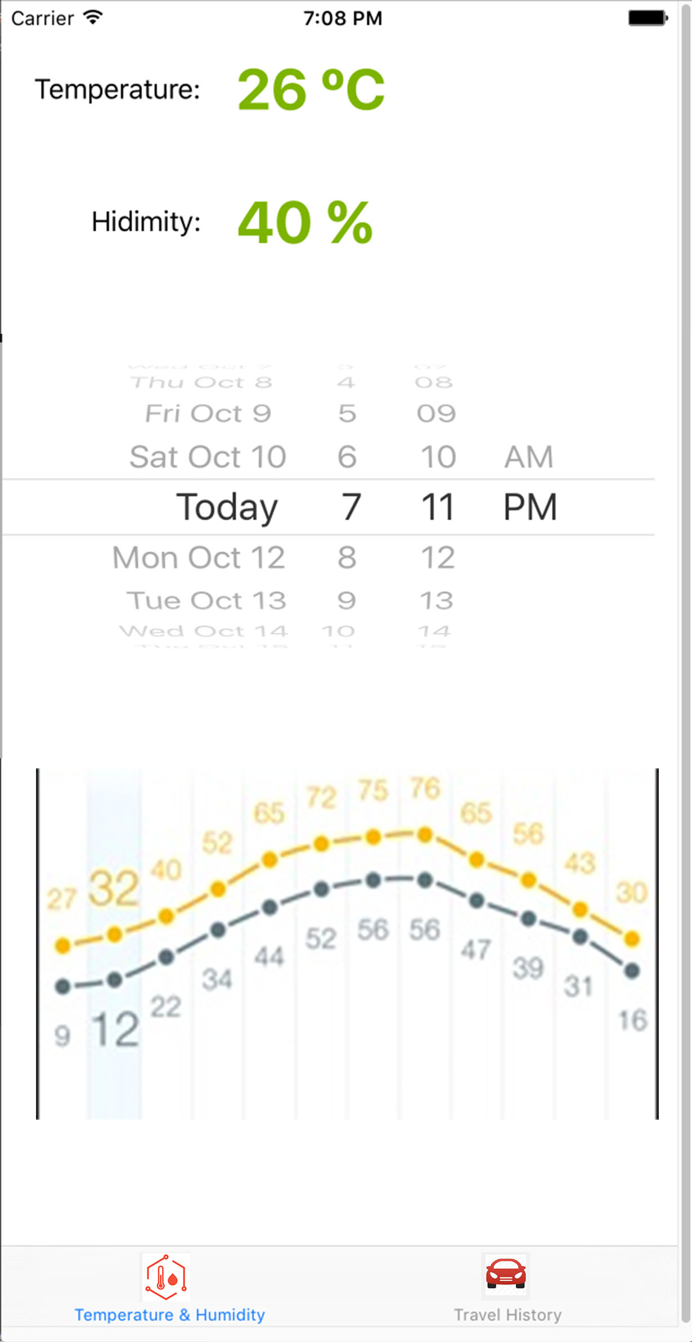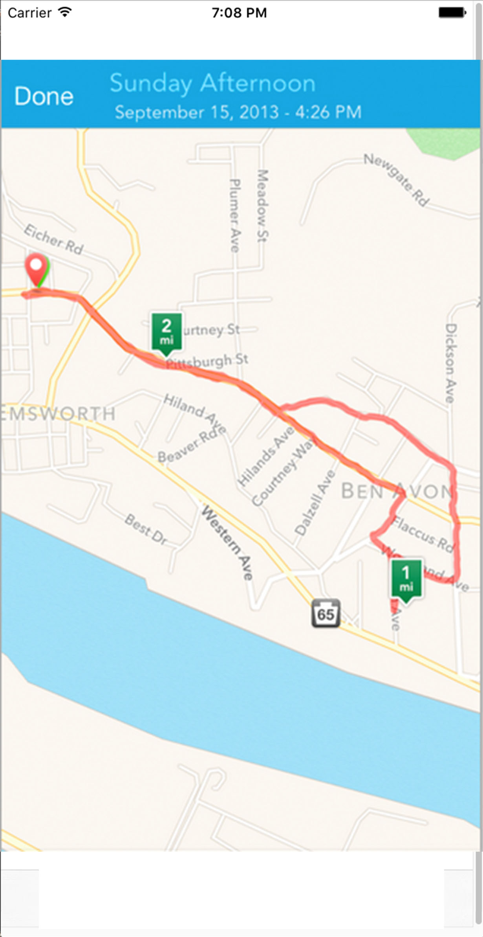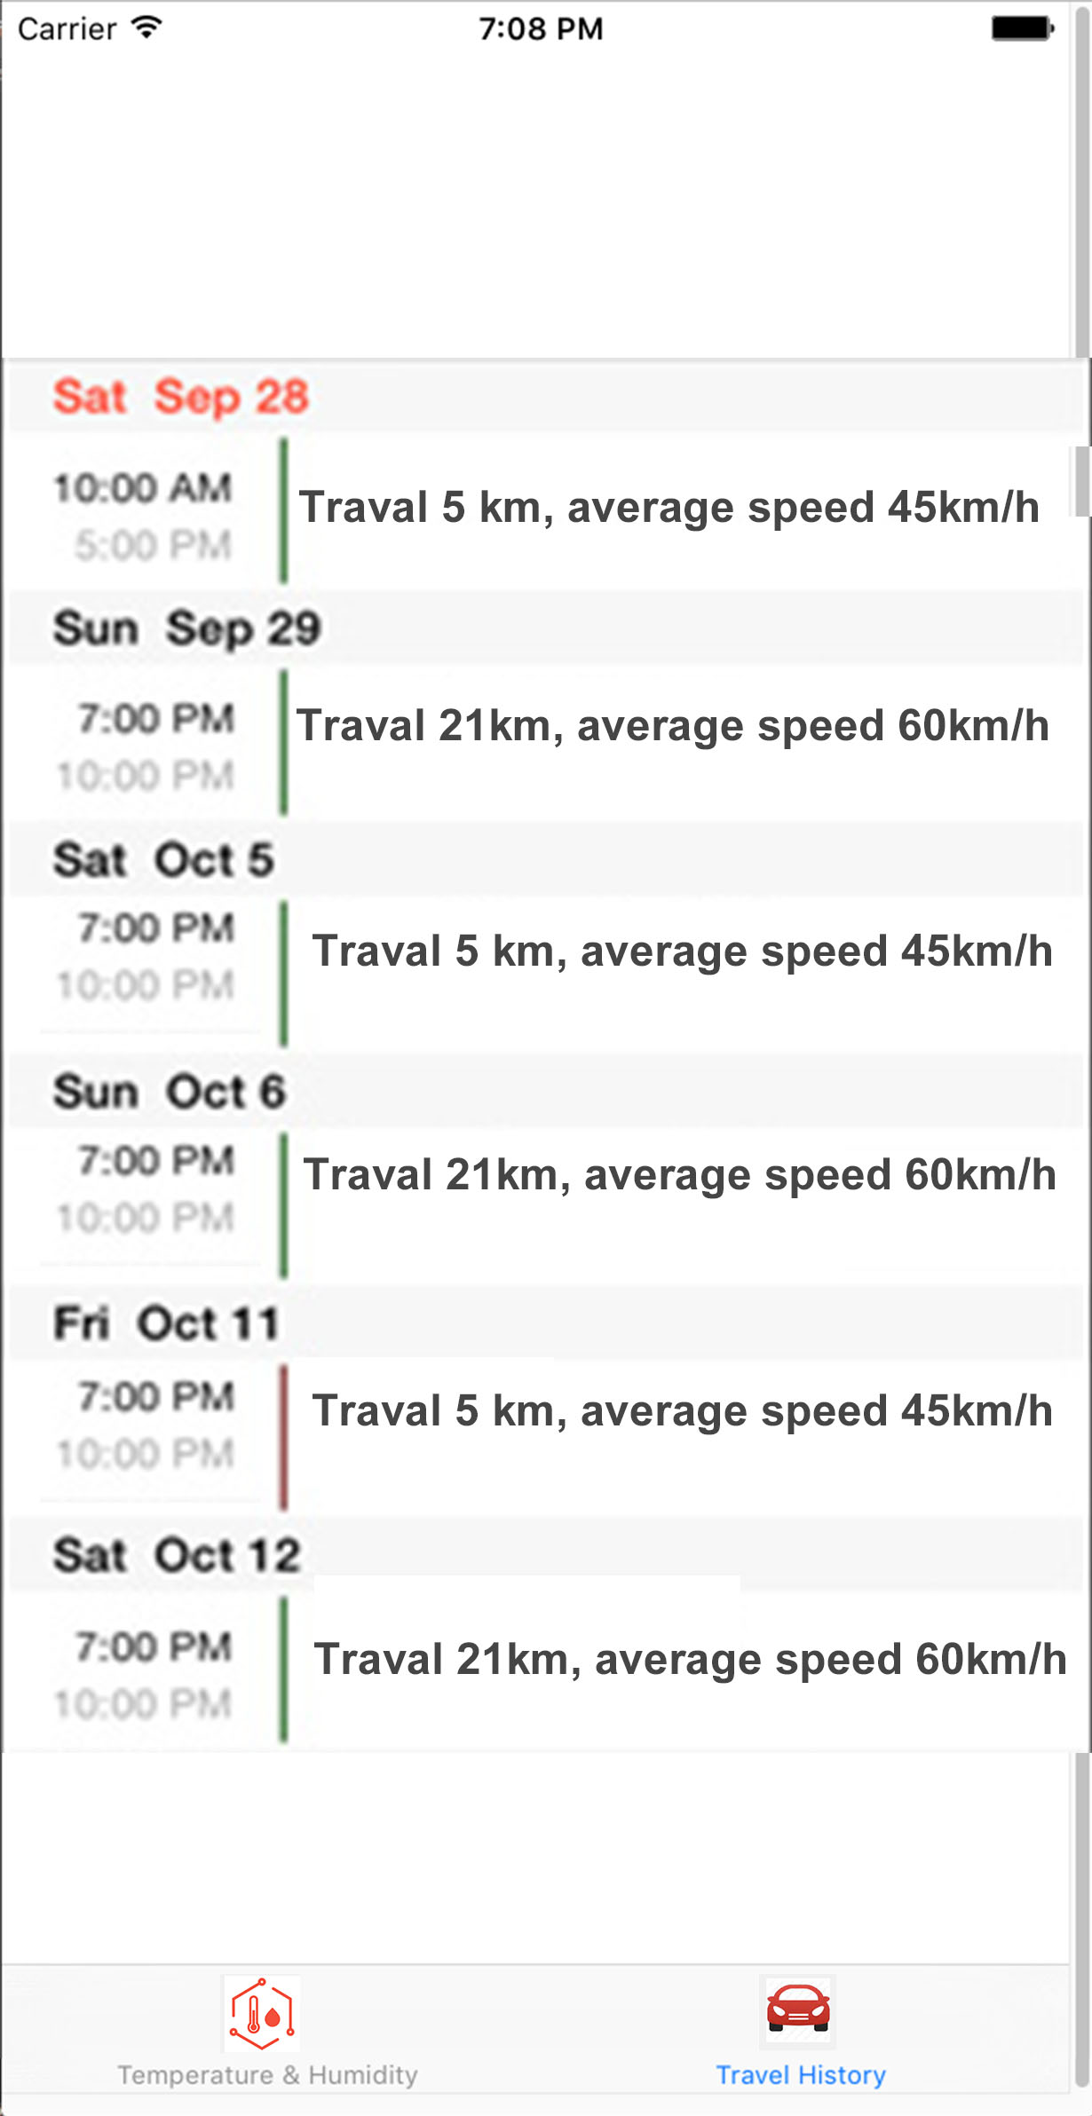

The iOS client consists of 3 screens.

First screen will show the current temperature and humidity. A line char indicates the historical temperature and humidity trends will display including a date picker as well.

Second screen will show the historical travelling record, with date, distance and average speed. Click a particular record will direct to the third screen that shows the travelling’s GPS track in a map.